Add User as Member for community:

<https://help.salesforce.com/articleView?id=How-do-I-add-myself-as-a-member-of-a-Community-if-the-Manage-Link-is-missing&language=en_US&type=1>

**Object Name:** Network Member Group

* NETWORKID
* PARENTID

EPAM Online Mobile Device: <http://mobilecloud.epam.com/#!/devices>

<https://mindmajix.com/salesforce/classes-inheritance-and-overriding-in-salesforce>

<http://www.infallibletechie.com/2017/07/salesforce-ownership-skew.html>

<https://developer.salesforce.com/blogs/engineering/2012/06/architect-salesforce-record-ownership-skew-for-peak-performance-in-large-data-volume-environments.html>

<https://santanuboral.blogspot.com/2018/09/Field-Service-Lightning-Consultant.html>

<https://salesforce.stackexchange.com/questions/122301/migrate-attachments-to-salesforce-files>

<https://douglascayers.com/2015/10/10/salesforce-convert-attachments-to-chatter-files/>

<http://sfcloudmesh.blogspot.com/2016/07/migrating-attachments-to-and-files.html>

<https://techevangel.com/2018/05/01/how-to-convert-attachments-to-files-in-salesforce/#more-230>

**Community Binary File(Manual UI Changes) Package.xml:**

<?xml version="1.0" encoding="UTF-8"?>

<Package xmlns="http://soap.sforce.com/2006/04/metadata">

<types>

<members>*</members>

<name>CustomSite</name>

</types>

<types>

<members>*</members>

<name>Network</name>

</types>

<types>

<members>*</members>

<name>SiteDotCom</name>

</types>

<version>43.0</version>

</Package>

**Convert MetadaAPI into sfdx format:**

sfdx force:mdapi:convert -r ./in -d ./out

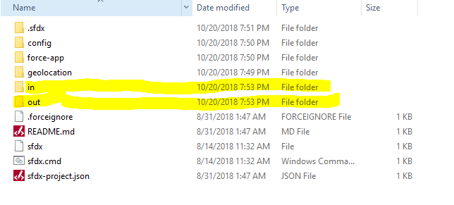

Keep MetaData all components file in **In** Folder and run **sfdx force:mdapi:convert -r ./in -d ./out** command. It Converts metadata components into SFDX format and paste in **out** folder.

<https://developer.salesforce.com/blogs/developer-relations/2017/04/lightning-components-performance-best-practices.html>

**DOS Command:**

<https://en.wikibooks.org/wiki/Windows_Batch_Scripting#EXIT>